Web Site Coding
Course Objectives:
This module is designed to run as part four of a modular course, designed to give software developers and testers a basic awareness into web technology and its place in E-Business.
In this fourth module, we produce static web pages using HTML and JavaScript and upload these pages to a web server. Later course modules will cover XML and server-driven dynamic web page creation.

Course Resources:
Supplementary tutorial materials are available at: http://www.classaxe.com/home

Students web pages will be uploaded to the course tutors web server where they will remain available for an indeterminate period of time* after the course has ended. The URL of each participating student’s site will be at:
http://www.classaxe.com/home/groupNN/username

The link to ‘Delegates Home Pages’ from the main teaching web site can be used to find your area if you are uncertain.

(*) This resource is provided on an “as is” basis by the class tutor and no guarantees are made for future availability of the resource once the course has concluded.

Course Entry Requirements:
Delegates will have previously attended the “Web Site Basics”, “Web Site Mechanics” and “Web Site Security” modules.

Additional Appendices:
Appendix A: Class Resources - Web site with examples, tools and YOUR published home pages
Appendix B: Updating your home page - Instructions on downloading and using an FTP program to update your web site once it has been published.
Appendix C: HTML Coding - A very basic listing showing some of the more commonly used tags and constructs used for creating web pages.
Appendix D: Hexadecimal Colour Representations - the complete Netscape 216 colour palette, plus why we need one.
Appendix E: Image File Formats - GIF, JPEG, PNG explained. Includes samples of files compressed to varying degrees using the JPEG format.
Appendix F: The ISO8859-1 Extended Character Set - how to get at symbols not shown on your keyboard, plus how to get around the problem of table cells “disappearing” when they contain no text.
Appendix G: Hexadecimal lookup chart - This chart may be used in place of one of the exercises in the book, and makes a handy reference tool for converting hexadecimal to decimal without a calculator.
A Historical Perspective:
The idea of a “Galactic Network” was first published in 1962 by J.C.R. Licklider in a series of memos in which he proposed a global system in which everyone could share data and access programs. The first limited incarnation of the Internet began life in 1969 as the US Military’s ARPA Net, with applications such as email and FTP forming the bulk of its traffic.
The World Wide Web devised by Tim Berners-Lee came into being in 1990/91 when he wrote the first web browser and server software initially just for the NEXT computer system.
The Hypertext Mark-up Language (HTML) which presently sits behind most of the web sites in existence is based on another language called Standardised General Mark-up Language (SGML) which was developed in the late 1980’s as a means for companies to share data and text files in a common format.
According to a survey by BrightPlanet.com, there are over 550 BILLION web pages in existence (one hundred for every human!) and only 1 billion of these are presently catalogued by traditional search engines.
Management Today reported a survey by Bain and Company predicting an annual net revenue for US based E-Commerce of $1,000 Billion by the year 2003.


References:- http://wwwmetrics.com/
http://www.brightplanet.com/deepcontent/deep_web_faq.asp
http://www.w3.org/People/Berners-Lee/
Management Today, November 1999
Tim Berners-Lee
Tools of the trade:
What do you need to create a web page? Actually, very little. A standard text editor such as Notepad (Windows 95/98 or NT4) should take care of the editing needs for a basic page, and any web browser can then be used directly to view the results. You don’t need a web server or even an internet connection to experiment with the basics. Later on you will probably want to add your own pictures and to make these you will require tools (some of which you can find on the support site) but for the time being we’ll just keep it simple. For real technophobes, editors such as FrontPage can produce pages without you ever having to see any raw HTML.
To run notepad, simply type “notepad” into the “Run” dialogue on the Start menu. Once you have written your page, save it as “c:\index.htm” and make sure you put quotes around the name, or notepad may try to be clever (failing spectacularly) and name the file “c:\index.htm.txt” (without telling you) which won’t work at all in a web browser. So why index.htm? The names “index.html”, “index.html” and “default.htm” have traditionally been used by developers to name the default page in a web directory.
Web browsers are very forgiving of mistakes in HTML code:- in the example above we failed to close a paragraph and mixed upper and lower case when coding the page, but most browsers don’t seem to mind.
HTML is NOT normally case sensitive, however when making links to external files (e.g. images) take care as many servers will differentiate between upper and lower case in file names- for example, a page may work fine on a Windows based server and fail completely on UNIX!
Also, don’t be tempted to try and use a word processor like Microsoft Word to write your HTML unless you really know what you are doing. Documents created in word may LOOK like HTML when viewed using Word, but will contain hundreds of extra hidden codes which word processors use to set up paragraphs, line spacing, fonts and the like. This WON’T work in a web browser.
Converting from other formats to HTML:
Many programs will allow you to save a document created in one format to another format.
Here we see the ‘Hello World’ page we created manually, but this time created using Word 97.

Problems with such conversions:
Word 97 has a tendency however to put in a lot of extra information which may make later manual modification of such files more problematic. Later we will learn about Style Sheets and use these to enhance our pages and provide for more centralised control of document formatting for a larger site. We will see how such things as specification of typeface are often better NOT defined in the actual body of the HTML, but in a single style definition line in the head - because Word 97 insists on specifying size and face for text it creates, we may be left with a lot of repair work if we wished to make global changes to our site.
You may also notice that the HTML generated is a lot bigger - 462 characters compared to just 173, an astonishing 250% increase over that created manually in notepad.
In addition, Word 97 here has failed to define the ‘Hello World’ level one heading as a heading, and simply made it bigger.
One further issue is that the META TEMPLATE construct may reveal information about the development file system we’d rather not make public - such as file server names or other network share path details and directory structures.
It also assumed the title instead of prompting us for it, but in truth this could have been set through the file menu under ‘Properties’ if I’d thought of it earlier. OK, so that’s my mistake.
Believe it or not, it’s made yet another mistake - both Font tags are closed out of sequence.

In fairness to Microsoft however, Word isn’t really built for this kind of thing.
Using a WYSIWYG Editor (‘What You See Is What You Get’):
For those who don’t like to think too much while they are programming, there are better ways to generate HTML than trying to use something like Word to export some very inefficient HTML.
The slide above shows how Visual Studio 2002 (which I use at home for VB.net programming) and as we can see, it’s produced pretty efficient HTML, at least compared with the dire efforts of Word 97 which we saw on the previous page.
A few quirks -:
- <STRONG> is used instead <B> ‘STRONG renders text in bold face’ (I guess that’s OK)
- <EM> is used instead of <I> ‘EM renders text as emphasised, usually in italics.’
- Some tags are defined as upper-case and others as lower-case (why?)
Now use of <strong> and <em> doesn’t present a problem as such - the tags work correctly on just about every browser since Netscape 2 and IE2.0, they just take a bit longer for documents to download that’s all. But perhaps I’m just being mean - on the whole Visual Studio is a pretty good example of this kind of editor.
Some of the many other editors I have used over the years:
Front Page Express Visual Studio 5
Front Page 95 and 97 Macromedia Dream Weaver
Front Page 2000 Netscape Composer (various versions)

However, nice though such tools are, we are not here to learn how to point and click.
This course module is designed to teach you how to understand HTML.
It is NOT an operating manual for ‘Visual Studio.NET’ (or any other WYSIWYG editor)

Validating Web Pages
The world’s authoritative source on what ‘is’ and what ‘is not’ valid HTML is the World Wide Web’s Consortium, still overseen by the web’s inventor, Tim Berners-Lee, but now assisted by many other member companies and organisations such as Sun, Netscape and Microsoft, all working together to devise the common standards in use today.
Their validation service is free and very widely used. To use it you should first ensure that your page is prepared for validation:
- Specify which of the available DTDs (Document Type Definitions) you wish your page to be tested against. See the list of valid DTDs supported by this validation service at
http://www.w3.org/QA/2002/04/valid-dtd-list.html
- Ensure that the W3C’s validator knows what character encoding your page has been prepared using. If you are testing a page by pointing to it’s URL, the web server sending that page to the W3C’s validator might send the character-encoding information in the form of an HTTP header. If not, or if we wish to override a default value with our own, we insert a <META HTTP-EQUIV> tag containing this information in the <head> section of our document. When a browser or, in this case, a validator, reads info in this kind of tag, it pretends it heard it straight from the web server dishing up the page, like this:
HTTP/1.1 200 OK
Server: Apache 1.3.5
Date: Wed, 15 Oct 1999 09:48:34 GMT
Content-Type: text/html; charset=iso-8859-1
Last-Modified: Tue, 14 Oct 1999 17:00:00 GMT
Content-Length: 250
The server didn’t really say
this bit - just pretend it did

HTML Exercise 1 (YES, already!)
Write a contact page for “The Hoyles On-Line Bookshop” using Notepad:- base it on the “Hello World” example created in notepad, invent some text, and ensure you do the following:
- Include opening and closing tags for <html>, <head>, <title> and <body>.
- In the <body> put a centred underlined heading
(<h1 align="center"><u>text</u></h1>).
- Follow that with a mailing address in a paragraph aligned to the right
(<p align="right">text</p>) leaving a new line between each line of the address (<br>).
- Include a main paragraph with justified text (<p align="justify">text</p>), with some of the words in italics (<i>text</i>), some in bold (<b>text</b>), some underlined (<u>text</u>), and some with all three together (you work it out!).
- Include one last paragraph where all the text is aligned once again to the default (left) with no extra formatting (you can use either <p>text</p> or
<p align="left">text</p>) .
- Somewhere in this final paragraph, include the following HTML code:
- <br><a href="http://www.torontocollege.com">Toronto College<sup>TM</sup></a>
- (What do you think this will do?)
- Save your page by saving it as described earlier as c:\hoyles.htm
- Test the page by typing type “c:\hoyles.htm” in the Start / Run dialogue box which should launch a web browser to display the finished page.
Note:
Remember to leave spaces between words (especially those where you have used formatting tags), use a <br> tag to force a new line (no closing tags needed with this one), and TEST your page before you claim to have finished!

Using “Color” and cracking HEX
Whenever you look at a colour picture, what you see is an illusion - the complete spectrum of colour is for humans a ratio of just three colours; Red, Green and Blue. This lets us produce any colour on a TV or computer screen simply by mixing them in proportion.
In HTML, colours can be named (<font color="red">text</font> for example), but with over 16 million to choose from, colours are often expressed as a three byte hexadecimal number. To change a page background colour to light yellow we can type <BODY BGCOLOR="#FFFF80">
Here the amounts of Red, Green and Blue are given as a 0-255 hexadecimal byte.
Hexadecimal is a convenient way of showing any number up to 255 (one “byte”) with two alphanumeric (Hex) digits. The units column goes not from 0 to 15, but instead from 0 to F.
0, 1, 2, 3, 4, 5, 6, 7, 8, 9, A, B, C, D, E, F
Once a number reaches F, rather than write “G” (and risk running out of letters really soon), we write “10” - in other words, one 16 and no units. When we say this out loud, we do NOT say “ten” which means something totally different, but instead pronounce it as “One Zero”.
This may seem a lot of hard work but is does mean that we can keep our three sets of figures (R,G,B) in separate groups of two digits, which ultimatly helps us work out what colours will look like on screen… we see that FFFFFF = white, or maximum levels of all three colours…
...FF0000 would therefore be red since only the red component is present… add a little of the other two colours to make the red a bit more “pink”… and we have FF2020. If we were to represent this as decimal instead we would get 16711680=Red and 16719904=pink.
Meanwhile we have 255=Blue and 256=(very dark) green. You can see how much harder this is to work with than hex. The hash symbol # tells the browser that what follows is a hex number.
You will find a binary to hexadecimal conversion table in the appendices at the end of this book. To represent a byte, simply use two hex characters, one for “16’s”, one for “units”.
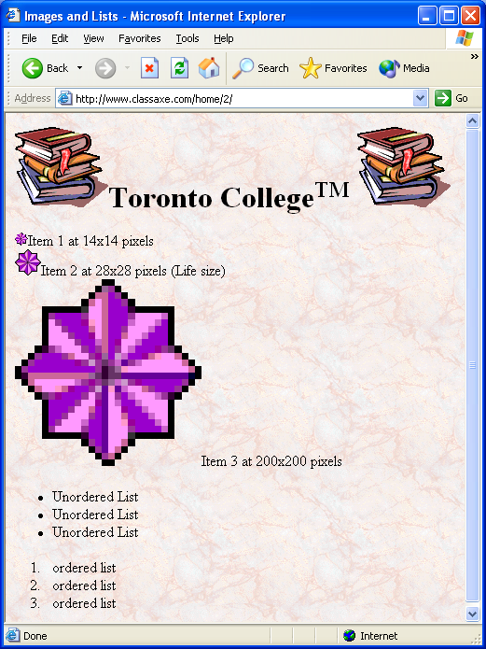
Images:
Having experimented with paragraphs, fonts and colours, it’s time to see how image files can be included in a web page. Images files are kept separate from HTML (unlike Word which normally copies images into the actual document along with the text). instead they are included by means of links. In this example we linked to an image for the background, and also to two other files which we have used several times in the same document.
To set a background image use:
<body background="(location)">
To include an inline image we could write:
<img src="(location)"> (note: no closing tag required in HTML - but XML users beware!)
It would be more correct to also specify the size and some alternative text if graphics are switched off. If the image is in a directory on the same server, we can link to it using a relative path as we see in the example above (../ means “parent directory” or “up one level” to a web server).
Your examples will run from your hard disk, so you will need to put a full URL path out to the internet to be able to link images into your web pages.
As an example, if you want to use the background above in YOUR page on the c: drive, you’d need to use:
<body background="http://www.classaxe.com/home/images/background1.gif">

Appendix E has information on the GIF, PNG and JPEG image file formats.
Image Maps
An image map is a list of co-ordinates used in connection with an image, that defines ‘hotspots’ on the graphic which can behave as hyperlinks.

Server-Side / Client-Side
There are two type of Image Map. Server-Side image maps are now rarely used. With this system, the act of clicking somewhere on an image causes the mouse co-ordinates to be sent to the web server, which then checks the list of co-ordinates supplied in the image map to see if any hotspot area has been activated. These image maps require active participation by the server.
Client-Side image maps are supported in all modern web browsers and in this system all processing to determine whether the user has indeed clicked on a hotspot area is performed in the web browser without web server intervention. Not only are such systems more ‘scalable’ because work is done on each web browser client instead of all centrally at the web server, but reaction time is also greatly reduced since a connection doesn’t have to be processed just to see whether the ‘click’ was in a hotspot area.

Client-Side Image Maps
In the example above, the image map itself is defined in the same document as the image that appears on the page. The image map has a name, in this example the name is mymap. To refer to this map, the reference ‘#mymap’ is given - the # indicates a position within the current document. Three classes of shape are supported:
- rect (give the X and Y co-ordinates for the top left and bottom right corners)
- circle (give the X and Y co-ordinates of the centre, plus the radius in pixels
- poly (for irregular shapes - give the X and Y co-ordinates for each point in the shape)
Use the ‘alt’ attribute to give ‘tool-tip’ information when the mouse is over a shape and remember to define parallel standard text type links for Braille readers and search engines.
Creating and modifying Graphics for Web Pages
It is important to be aware of some of the features available in graphics editors and to be able to choose one suited to the purposes of producing graphics for the web.
‘Cropping’ and ‘Resampling’
Modern digital cameras typically produce 1600x1200 pixel photos. To display on a smaller screen, and have the graphic download in a reasonable time, you can ‘resample’ to make the image smaller. You may also want to ‘crop’ the image to cut off the edges you aren’t interested in.
Sharpening
After resampling a photo, some clarity may be lost and the picture may become a little ‘fuzzy’. It is often necessary to restore some of the ‘sharpness’ by means of some kind of ‘sharpen’ filter.
Airbrushing and Cloning
If it’s your photo on your own site, and if there’s no ethical reason not to, you can use ‘airbrushing’ and ‘cloning’ techniques to remove details from the photo which are irrelevant or confuse the viewer. Cloning lets you selectively copy one area of the picture into another, airbrushing sprays a single colour into the selected area in a dissipated manner - like an airbrush!
Brightness and Contrast and Softening
You can often make a picture much clearer and brighter using such techniques. Conversely, if there’s a picture you’d like to use as the base for a page background, you can ‘wash out’ the picture by making it lighter and reducing the contrast to maintain texture but make it less confusing to readers when text is superimposed on it. Softening helps make the background less obtrusive.
Adding text
You can create text buttons or captions for pictures and have more control over fonts than you’d otherwise get simply by placing HTML text in the page - but remember alt text for search engines and Braille readers. If you start off working in 16 million colour mode, fonts can be ‘anti-aliased’ to smooth the edges by using intermediate colours. You can reduce the colours later.
Animated Graphics
There are several ways to include animated graphics in a web page:
- Insert animated .gif files as you would use a standard graphic
I use Paintshop Pro Version 5.0 which comes complete with Animation Shop, available from JASC Software’s site at http://www.jasc.com
- Embed an AVI file (download may be large). Syntax:
<IMG DYNSRC="movie.avi" SRC="movie.gif" LOOP=INFINITE START=MOUSEOVER CONTROLS>
The file move.gif is displayed until the user moves the mouse over the graphic, then the movie movie.avi (provided it is already fully loaded), begins.
- Use Javascript to step through an array of images (requires Javascript to be enabled)
- Embed a ‘Flash’ animation in page (requires Flash Player browser extension installation)
Flash MX is available for people teaching or enrolled on computer courses for just $99US (an absolute bargain compared to it’s normal price) - see a sample I created for a course I taught at University Of Greewich (UK) - http://www.classaxe.com/wireless/data/demo
- Embed a ‘Director’ animation in page (requires Shockwave Player browser extension installation)
- Embed a Real Media file in a page (requires Real Player)
Helix Producer is available for Free from http://www.realnetworks.com/products/producer/
- Embed a Windows Media Player file in a page (requires IE and Media Player).
Exercise Time again folks…
Create a graphic and place it on your web page, using Paintshop Pro V5 - if this is not already installed on your PC, ask the lecturer.
Now create an animated graphic gif - a scrolling image of your name - add this to your page.
Freedom for all!
The internet is a tremendous gift to people with various disabilities - it can open up a wealth of information and community access which might otherwise be beyond normal reach of many people affected by such problems as partial or complete blindness, loss of hearing or impaired motor functions.
These days, information providers must adopt a pragmatic approach to serving the needs of their community and must ensure that web pages are accessible by people with special needs - in many cases, governments and companies are compelled to provide adequate support for these people of face possible legal consequences.
Standing in someone else’s shoes:
Consider people with poor vision - try someone else’s glasses on for a moment -
- How does the page look?
- Is it still easy to read?
- Did you write your code in such a way that small text cannot be made bigger?
Now imagine having to hear a blindfold over your eyes while using the web - using a text to speech machine to read the page contents to you.
- What clues would you miss?
- What information would be hidden
- What links to other content would be inaccessible?
Perhaps your reader is colour blind? Or deaf? Does your page still work? No? Fix it!
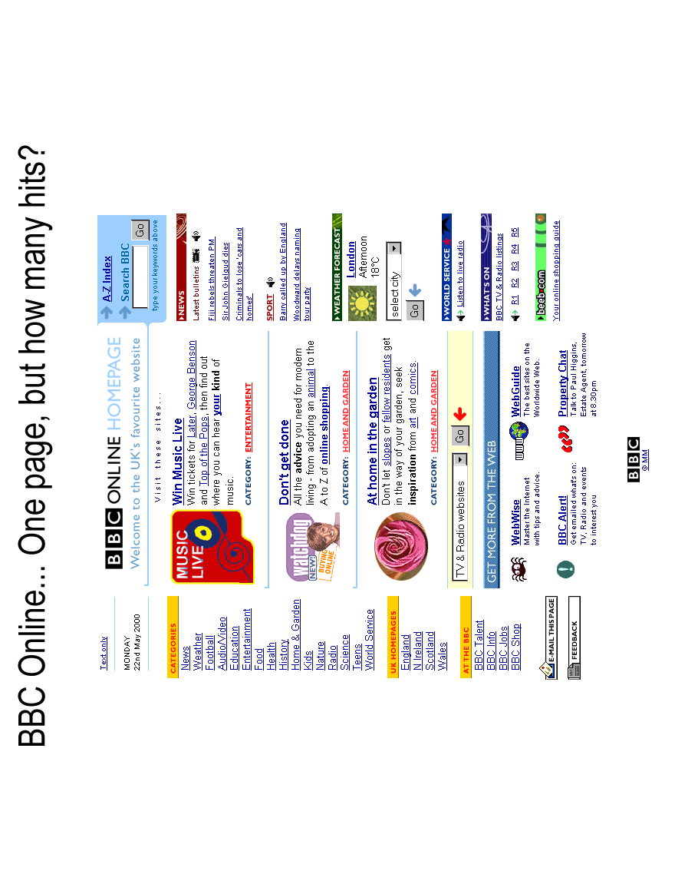
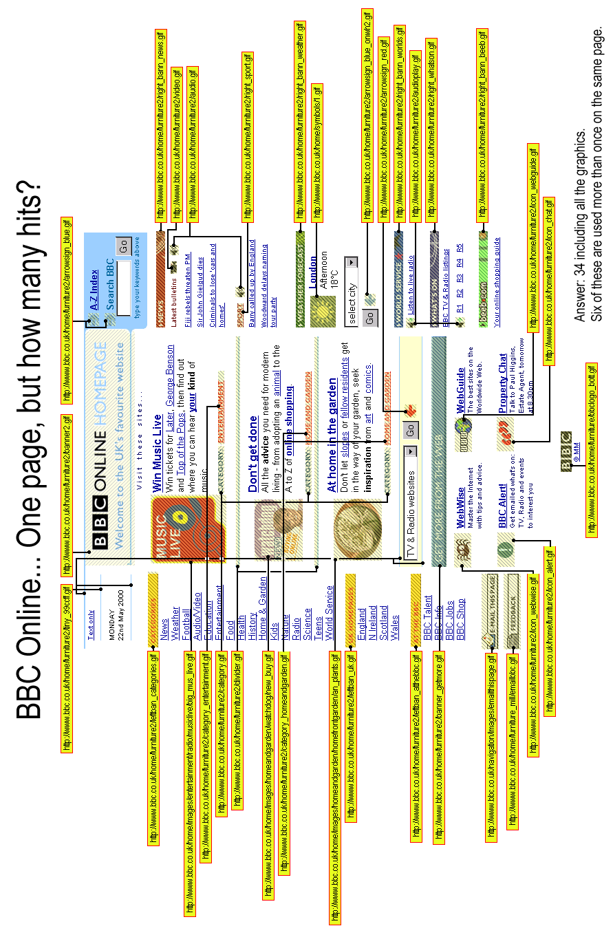

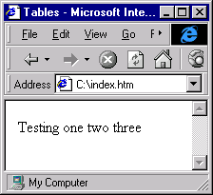
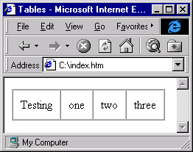
Table Times:
Assuming that the code is typed in as shown, enclosed of course in <html> and <body> tags, you should get the result shown here to the right, which to be honest, DOESN’T look very “table-like”, since you can’t see any of the lines which make it look like a table.
If we modify the code for the <table> tag to include some parameters, we can have much more control over the way the page is displayed. The tag and parameters used here are:
<table border="1" cellspacing="0" cellpadding="10" >
By specifying a border of “1” this sets the width of the border to one pixel.
Cellpadding specifies the amount of space inside each cell from any contents (internal margin if you like).
If we specify cellspacing=“5” we get this:
Aligning Tables:
<html>
<head><title>Aligning Tables</title></head>
<body>
<table border="1" cellspacing="3" cellpadding="6" width="60%">
<caption>Table with text aligned differently in each cell</caption>
<tr>
<td width="30%" height="60" align="left">Left</td>
<td width="30%" height="60" align="center">Center</td>
<td width="30%" height="60" align="right">Right</td>
</tr>
<tr>
<td width="30%" height="60" valign="top">Top</td>
<td width="30%" height="60" valign="middle">Middle</td>
<td width="30%" height="60" valign="bottom">Bottom</td>
</tr>
</table>
</body></html>

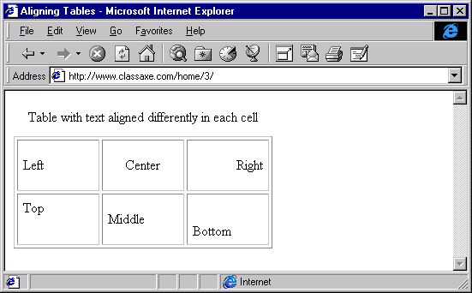
Type in this URL and try resizing the window…
Which bits shrink? Which bits don’t? (Why?)
It doesn’t matter that the widths add up to 90%, not 100%.
Cell sizes are always in proportion to the size of the table (60% of the screen size in this case)
Merging Tables:
The web page shown in the slide is created by the following code. A real page would have relative paths for loading the graphics elements, as this makes moving the page easier. The use of absolute paths however allows you the student to make this page work as it is, from your computer’s hard disk. You will also note that this time the table size is set to an absolute value of 400 (pixels), so try resizing the web page window on this example and compare the effect with resizing of the window on the previous example. (http://www.classaxe.com/home/3/ and http://www.classaxe.com/home/4/)
<html>
<head><title>Merging Table Cells</title></head>
<body background="http://www.classaxe.com/home/images/background1.gif">
<h1><font color="Green">Merging Tables</font></h1>
<table border="1" cellpadding="2" cellspacing="2" width="400">
<tr>
<td bgcolor="#25B4E2">1</td>
<td bgcolor="#008080">2</td>
<td colspan="2" rowspan="2" bgcolor="#FFFF00">3</td>
</tr>
<tr>
<td colspan="2">4</td>
</tr>
<tr>
<td colspan="2" rowspan="2" bgcolor="#00FFFF">5</td>
<td>6</td>
<td rowspan="2" background="http://www.classaxe.com/home/images/background8.gif">7</td>
</tr>
<tr>
<td>8</td>
</tr>
</table>
</body>
</html>
HTML Exercise 2
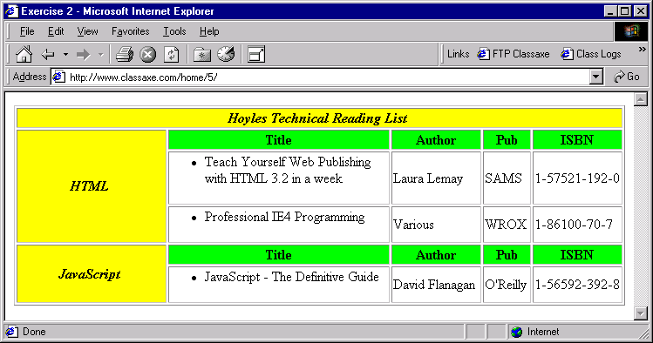
Create a web page to display the table shown below and in the slide:

Make sure you set the width of the table to 100% (therefore relative). Don’t bother to do anything with height. The text in each cell is centered and the text “Hoyles Technical Reading List”, “HTML” and “JavaScript” is set to bold and italics. The yellow shaded cells “#FFFF00” and the green ones are “#00FF00” . The table itself has a border of one and cellspacing and cellpadding are not used, so take instead their default values.
Try and avoid sneaking a look at the solution until you have at least made a reasonable attempt at solving this exercise for yourself. (http://www.classaxe.com/home/5/index.htm)
You’ve Been Framed!
Many web-sites make extensive use of frameset documents. The URL entered into the address field of the web browser is for a document which in turn causes other documents to load on top of itself, causing split screen views of perhaps many other documents. This allows information from several sources to be combined on a single screen. This has advantages and disadvantages, and not every web user approves of this technique. The use of framesets makes it less straightforward to “bookmark” pages of interest, as the URL stored will normally be that of the base document rather than a subframe document. Note that the example above is NOT that listed below.
Frames allow an area to remain fixed on the screen, even whilst other regions are being scrolled. This can be used to ensure that a side bar menu or a company information header is always visible on a screen. Don’t ask a document to load itself into its own sub frame (the equivalent of asking a snake to swallow its own tail!), as this may cause a crash. This page is on the web at http://www.classaxe.com/home/6/
<!DOCTYPE HTML PUBLIC "-//W3C//DTD HTML 4.01 Frameset//EN">
<html><head><meta http-equiv="Content-Type" content="text/html; charset=iso-8859-1">
<title>Simple Frames Example</title></head>
<frameset rows="220,*">
<frame name="header" scrolling="no" noresize src="../1/index.htm">
<frame name="main" src="../2/index.htm">
<noframes>
<body>
<p>This page uses frames, but your browser doesn't support them.</p>
</body>
</noframes>
</frameset>
</html>
For older browsers - but these days used more for search engine support
(see section in Web Site Mechanics
The document has no <body> and goes straight from <head> to <frameset>. Source paths are relative to location for THIS document; - yours might not be.
More fun with Hyperlinks:
So far we have only used the <a> tag as a hyperlink, in fact I often refer to the <a> tag simply as a hyperlink. That is a mistake, because its operation is rather more subtle than that. Here’s a better way of looking at it: to use an anchor as a hyperlink, we add the href attribute and specify the name of the file we wish to see. However, even that is an oversimplification because we can also navigate to a given position within a specified document, by means of the #name system. To navigate to a given position in a document, we have to use the <a> tag in a different way and define a ‘named anchor’ which the actual hyperlink can then navigate to.

Creating a named anchor
Simply add a name attribute and set it to whatever name we wish to refer to later on, as shown in the slide above.

Specifying a target
Now we know what a frameset document is, we can discus how to click on a hyperlink in one document inside a frame and get it to change the location of a document in another frame. This is commonly used to create a menu type of system, where we have a menu in one frame which changes the content loaded in another. It’s very effective. To do this, when we define the hyperlink we need to add a target attribute to the hyperlink.
Some values for target have special meanings:
“_top” means replace the top-level frameset altogether
“_blank” means open a new window and put the content into that.

Sending an email
To create an email link, we specify mailto: in the href attribute. What follows is the email address we wish to address the message to. See the slide for how to set the subject line too!
Practical State Management:
Earlier (in Web Site Basics) we learned about ‘State Management’ - web servers have to keep track of the contents of countless ‘shopping carts’ or interact on an individual basis with many users at various stages of completing sequential transactions. We also learned the web servers tend to ‘hang up’ the connection after each and every request by the client, and that all of those browsers out there can tend to look alike - this can make it hard to recognise each machine as they reconnect to perform the next stage in any transaction they are in the process of completing. There are two main techniques used by web servers to recognise individual client machines out there and make some kind of order from the chaos. Both techniques require the web server to take control of the session and lay down the rules clients must follow in order to interact with it.

Hidden Form Fields:
The client requests the default web page. If the browser sends no additional parameters, the server concludes this is a new customer beginning at step one of the process. The server issues a unique ID (one it isn’t already using to describe a session with some other client) and sends the page requested. That page contains a form with at least one ‘hidden’ field - that is, a field with a name and corresponding value that, while present, is not actually displayed on the screen. The value in that hidden field is set to the unique ID (sometimes known as the ‘Key’) which will be used to identify this client for the remainder of the session. Once the user has completed the visible portion of the form, they press ‘Submit’. The form has a predefined ‘action’ - normally the name of a script on the web server which will be executed in response to the submission. The contents of all the form fields (including any invisible ‘hidden’ ones) are with the submission and passes to the script as parameters. The script then executes the action required (after looking at the parameters), and responds with another form - this new form contains the SAME key the server issued earlier, in a hidden field. When the user completes this stage and presses ‘Submit’, that same ‘key’ is sent. Thus the key can ‘follow’ the user round the site, from page to page, throughout the process.
Cookies
This time the browser arrives at the door without bearing a free gift (a cookie), and so the web server asks the browser to create and store a cookie which just happens to contain a unique ID. The response from the server concludes with a ‘redirect’ (Normally ‘Page moved: Code 302), telling the browser to come right back to the same location.
The browser does as it’s told and comes right back to the same place it just tried a moment ago - only now, it has a cookie with it, and that cookie contains the unique key the server needs to convince it that this is from a browser which has cookies enabled and is ready to ‘do business’.
Cookies can be supplied with a ‘best before’ date - if this happens, the web browser Stores the cookie in it’s cookie cache, and will continue (for weeks and even years to come) to send that cookie each time it accesses the page that the cookie belongs to. If the browser accesses the site later, but the expiry date on the cookie has passed, the cookie is deleted and the web server, seeing no cookie this time, issues instructions to create a fresh one.

Sessions
… may be used with either cookis or hidden form fields. A session is stored on the web server (normally either in RAM or in a database record) and allows a single unique key to access a whole store of information about this user or set of transactions. Like pulling your personal file.

What happens when you don’t send the right codes to the server?
Imagine baking a cake for a neighbour. You decide what to make. You make a list of ingredients. You go out and buy everything you need to produce it. You mix it all together in the correct proportions and cook it in the oven. Finally, you put the cake on a plate and go next door to deliver the cake. You knock on the door, but when the neighbour asks “who is it please?” you don’t answer - you didn’t hear the question. Assuming that the door has now opened, you walk straight into it, smashing the plate, cake, and yourself, all over the door. So close and yet so far. To bad you didn’t listen to the neighbour first - Dough!
Forms in HTML:
So far in this course we have just produced static pages. We need to learn about interacting with web services, and one way to do so is to use HTML Forms. This page is static but in real life it would normally have been supplied dynamically by the web server - how do I know this? It makes sense - the page has a hidden form field: that’s the kind of trick a web server would use to track a session. For now however, let’s fake it. The application we will contact is REAL however.

Forms and Elements:
When you click on an ordinary hyperlink, an HTTP GET command is issued by the web browser to the web server, asking for new content. It is possible, using Forms within HTML, to have the web browser ask the web server to find and execute a script, using additional parameters sent by the browser to affect the way in which the script is executed on the server. In this way, we can create a simple form and use it to submit queries to a search engine site, or any other web application built to process such information. There are two methods used for sending form data:
GET Appends form data to the URL of the script run on the server to process the output. You can bookmark the script URL with all submitted form fields intact, perhaps to save frequently used searches on a search engine. BUT: Security risks & size limits.
POST All form data is sent as name=value pairs as headers in the HTML request. There is no size limit but you can’t bookmark the script with form field data intact.
<html>
<head><title>Forms</title></head>
<body><h3>Example of a simple form</h3>
<form action="http://www.classaxe.com/home/test.php" method="GET" name="myForm">
<input type="hidden" name="Visitor" value="007">
Name: <input type="text" name="Name" size="20">
<input type="Submit" name="Confirm" value="GO">
</form>
</body></html>
Change the method to POST and try that too!
The value for this hidden field
would normally be supplied by the server & used for tracking.
Create the html file shown above, save it as c:\form.htm and try it.
List of other commonly used Input Types for forms:
- Password Fields Replaces typed text with asterisks (*)
- Select A dropdown list containing several <option> elements
- Checkbox If ‘checked’, field value is sent to server
- Radio If several have the same name, they act as a group
- Textarea For larger areas of text, such as ‘Memo” fields.
<html>
<head><title>Forms</title></head>
<body><h3>Example of a simple form</h3>
<form action="http://www.classaxe.com/home/test.php" method="GET" name="myForm"> <input type="hidden" name="Visitor" value="007">
Name: <input type="text" name="Name" size="20"><br>
Pass: <input type="password" name="Password" size="20"><br>
Food: <select name="Select">
<option value="Pizza" selected>I Like Pizza</option>
<option value="Pasta">Pasta Please</option>
</select><br>
Extras:<br>
<input type="checkbox" name="Checkbox[]" value="Drink"> Can of Pop<br>
<input type="checkbox" name="Checkbox[]" value="Fork"> Plastic Fork<br>
<input type="checkbox" name="Checkbox[]" value="Hat"> Party Hat<br>
Cheese Topping:<br>
<input type="radio" name="Radio" value="0" checked> (None)<br>
<input type="radio" name="Radio" value="Mo"> Mozzarella<br>
<input type="radio" name="Radio" value="Ch"> Cheddar<br>
<input type="radio" name="Radio" value="Sw"> Swiss<br>
<textarea name="Textarea" cols="40" rows="3">Comments?</textarea>
<input type="reset" value="Clear Form">
<input type="submit" name="Confirm" value="GO">
</form>
</body></html>
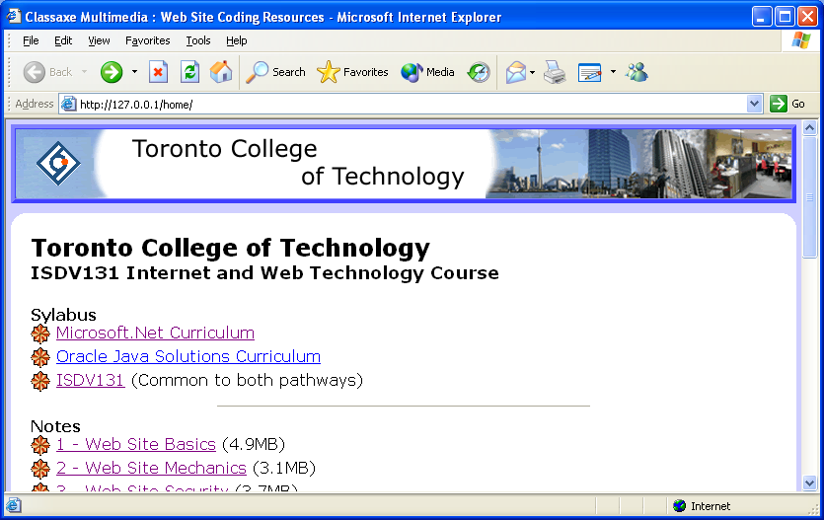
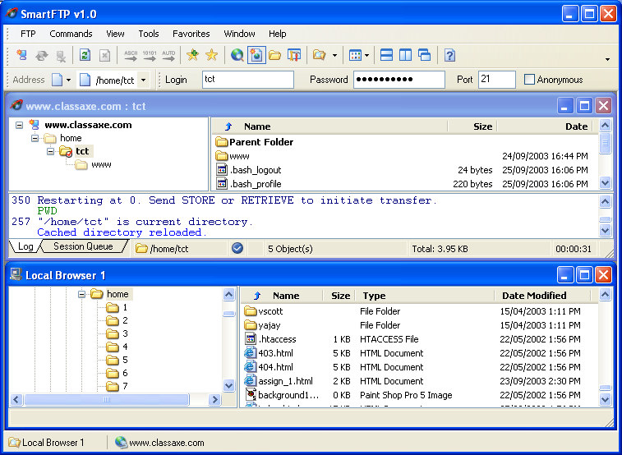
Appendix B:
Updating Your Home Page
You can find a copy of a very fine shareware FTP package by following the link for Smart FTP from the course page.
Use the settings shown below.
Once you have entered the required details, open the FTP connection and navigate to your folder - this should be named with your initial and surname.
Now open a local browser to enable you to transfer files from it to the your home directory.
Here are the FTP access settings:
Host: www.classaxe.com Username: tct Password: w5te74jjp1

Please note - this facility is provided ‘as-is’ by the course lecturer and it may be removed at any time.

Please do not exceed 100KB of content in your home directory or it will be deleted.
Appendix C: HTML Coding
<HEAD> … </HEAD>Information describing the document, such as:
<TITLE> … </TITLE>Contained in the head, no other formatting possible.
<script language=“JavaScript”> … </script> JavaScript code - may be in head or body.
<META name=“Description”> content=“for search engines”>(No closing tag)
<META name=“Keywords”> content=“for search engines”>(No closing tag)
<HTML> … </HTML>Whole document is normally enclosed by these tags.
<!-- All this is a comment, may span several lines, up until this point here... -->
<BODY> … </BODY>The displayable part of the document
Optional parameters in opening tag:
background=“url”Causes a background image to be loaded for the body
bgcolor=“#color”Colours the background - overridden by background
text=“#color”Sets default colour for all text in document
link=“#color”Sets default colour for all un-visited links in document
vlink=“#color”Sets default colour for all visited links in document
onload=“jscript”Executes script after document has loaded.

<Hx> … </Hx>Specifies a level x heading where 1 is largest, 6 is smallest.
Optional parameters in opening tag:
align=“(alignment)”Specifies alignment. May be left, right or center.

<P> … (</P>)A paragraph containing actual content. (Closing tag optional).
Optional parameters in opening tag:
align=“(alignment)”Specifies alignment. May be left, right, center or justify.
Common text formatting modifiers: (if nesting, close tags in reverse order)
<BR>Forces a new line. (No closing tag)
<B> … </B>Enclosed text is in bold (similar to <strong>).
<I> … </I>Enclosed text is in italics (similar to <em>).
<U> … </U>Enclosed text is underlined.
<HR>Specifies a “Horizontal Rule” - a line separating two areas of
text. You can specify size=“n” and width=“n%”
<A> … </A>An anchor, normally used as a hyperlink or bookmark.
Optional parameters in opening tag:
name=“bookmark”Specifies name to be given to a bookmark.
href=“url”Links to another file or resource.
href=“mailto:a@b.com”Creates a link to a mail program, and to email address given.
href=“#bookmark”# links to this same page, but to a particular bookmark in it.
target=“destination”Species the destination for href= to be loaded to.
onmouseover=“jscript”An “event trigger” for a previously loaded JavaScript routine.
onmouseout=“jscript”An “event trigger” for a previously loaded JavaScript routine.
<FRAMESET rows=“100,*”> (Other options: cols=“*,100,50” where “*” = “remainder”)
<FRAME name=“menubar” src=“menu.htm” scrolling=“no” target=“main”>
<FRAME name=“main” src=“main.htm” scrolling=“yes”>
<NOFRAMES> <BODY>Sorry, this page needs frames</BODY></NOFRAMES>
</FRAMESET> (A frameset is used instead of a body)
<IMG src=“url”> An image file. Acceptable formats are .gif, .jpg or .png
Optional parameters (no closing tag):
width=“width” Width (normally in pixels).
height=“height” height (normally in pixels).
alt=“alternative text” Text to use if image switched off, unobtainable, or still loading.
hspace=“n” Space to leave to left and right of the image.
vspace=“n” Space to leave to top and bottom of the image.
align=“alignment” Specifies how text should align around the image. Options: left / center / right / top / middle / bottom / texttop / absmiddle / absbottom
<FONT> … </FONT> Changes the writing font for the enclosed text.
Optional parameters in opening tag:
color=“color” Specifies a colour (either named or as a #hex “triplet”)
size=“n” Changes font size to n (n=“1” is smallest, n=“8” is largest)
face=“face1, face2” Changes to named font, or alternative if not available.

Unordered (bulleted) list:
<UL> You may also specify type=“circle”, “disc” or “square”.
<LI>list item 1</LI> Each item has an opening list tag, and closes with another.
<LI>list item 2</LI> Lists may be nested by opening new ones before closing.
</UL> Closes the list.

Ordered (numbered) list:
<OL> You may also specify type=“A”, “a”, “I”, “i” or “1”
<LI>list item 1</LI> To start a list at a certain number, use “start=“n”.
<LI>list item 2</LI> Elements can use value=“n” to specify value.
</OL> Closes the list

Tables:
<TABLE> … </TABLE> Container tags for a whole table
Optional parameters in opening tag:
width=“width” Width in pixels (or use “%” for percentage of available area).
height=“height” height (normally in pixels).
border=“n” Size of border around entire table in pixels
cellspacing=“n” Space to leave between each cell.
cellpadding=“n” Space to leave between contents and border of each cell.
<CAPTION>…</CAPTION> Caption text. Can use align=“top”, “bottom”, “left” or “right”.
<TR> … </TR> Table rows containing table cells.
<TD> … </TD> Table data cells.
Optional parameters in opening tag:
background=“url” Causes a background image to be loaded for the cell.
bgcolor=“#color” Colours the background - overridden by background.
width=“n” Width in pixels (or use “%” for percentage of available area).
height=“n” Height in pixels (or use “%” for percentage of available area).
align=“n” Specifies horizontal alignment within cell (left, right, center).
valign=“n” Specifies vertical alignment within cell (top, middle, bottom).
colspan=“n” The number of columns this cell is to span.
rowspan=“n” The number of rows this cell is to span.
Appendix D:
Hexadecimal Colour representations
This colour palette represents the 216 colour palette devised by Netscape to promote a standard colour set to be used in Web graphics. The idea behind this is that older graphics cards equipped with only 256 colour 8 bit graphics cards need perhaps as many as the first 40 colours to provide basic operating system support (background colours, menu bars etc), leaving 216 available for other purposes (such as web graphics).
By choosing colours in this palette, the developer can be certain that even the most basic 256 colour graphics cards will display the shades correctly without having to resort to “dithering” - that is, using dots of other colours to simulate the intended colour, which can leave a grainy looking image when viewed in these “unsafe” colours.
There are many examples of helper application on the web to aid in selection of colours for Internet use, one such may be found at: http://the-light.com/colclick.html
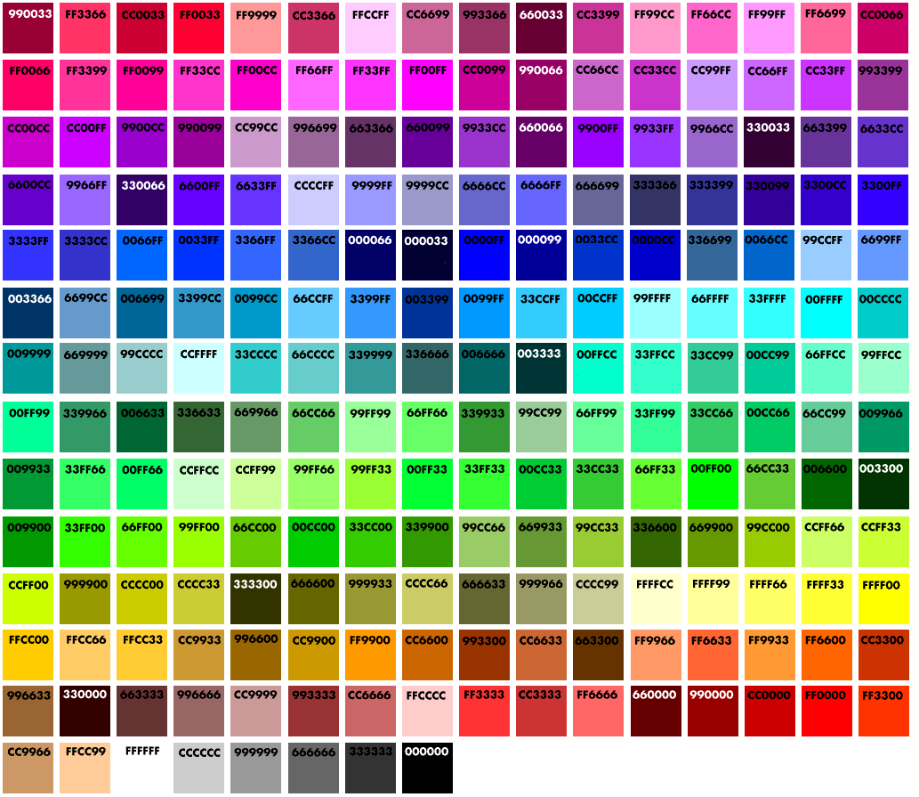
Appendix E:
Image File Formats
There are literally thousands of different formats in use to encode graphical images. These range from formats used to describe the shape of letters in different fonts to the massive resolutions and specialised colour rendering of images from meteorological satellites. It was decided early on that a limited sub set of common graphical formats should be adopted for web site use. The present list includes three formats:
- GIF (pronounced “djif”)
- JPEG / JPG (pronounced “Jay Peg”) and
- PNG (pronounced “Ping”)
GIF - Graphics Interchange Format:
The first image format to gain widespread acceptance was the “GIF” used by Netscape in one of their early browsers, and developed by CompuServe some years earlier back in 1987.
It is a compressed format to make downloading faster, and is normally capable of displaying only 255 colours at any one time. It is recommended that the Netscape 216 colour palette described in Appendix D is used with all such images, to prevent “colour shifts” experienced when viewing more than one image with differing palettes simultaneously, on low colour mode video cards. The use of so few colours can result in the requirement for the image to be “dithered” prior to export however, in order to approximate colours not included in the palette. This can make the image appear a bit “grainy” to the eye. The answer to this is to carefully select colours which conform to the standard palette before hand where possible. This works better with some images than others however: graduated fills and other such surfaces require a range of many colours to be convincing.
GIF images allow some other special features: a colour from the palette may be specified to be transparent, enabling buttons or shapes with round or non shaped edges to be loaded into a page, whilst enabling the transparent parts of the image to let the background appear behind them, rather like a stained glass window may be painted onto an otherwise transparent support medium.
GIF images can also allow simple animations to be created, a really big deal back in the early 1990’s when the Netscape browser first provided web support for them.
See http://members.aol.com/royalef/gifabout.htm for more details on animated GIF files.

GIF Legal Problems - enter PNG
The format was hit by an unexpected problem however when in 1995 the patent rights to the LZW compression algorithm were sold to the Unisys corporation. Despite earlier protestations to the contrary, since July 1999 Unisys insist that everyone creating software to build GIF files must obtain a licence from them. This caused an outcry, and many sites have replaced GIF files with files in the newly created “PNG” (Portable Network Graphics) format in protest.
Besides the small percentage of sites in this category, there has not been much use made of the PNG “freeware” replacement for GIF files format made yet, but expect this to change.
It’s a fascinating story. Read about it at http://lpf.ai.mit.edu/Patents/Gif/Gif.html, and if that doesn’t shock you, have a look at http://burnallgifs.org

Appendix E:
Image File Formats (continued)

JPEG - “Joint Photographic Experts Group” format:
JPEG files can contain a huge number of colours - 16.7Million to be precise, if you are talking about colour, or 256 shades of grey if you are happy to use black and white for your pictures. It uses a whole suite of compression routines which can results in very small file sizes for the highest compression ratios. Unlike GIF, the compression is “lossy”, that is, the smaller you make the image file, the more unreal the image looks.
The system was originally developed for use by photographers promoting and storing their work, and with the huge number of colours available the format is ideal for pictures of real world organic objects or photographs of scenery, since mathematical accuracy is less important than aesthetic effect.



Here are some examples of images of files with increasing levels of compression:
Compression 1% Compression=30% Compression 60%



Size=32.1KB size=8.0KB size=4.7KB
Compression 90% Compression=95% Compression 98%
Size=1.9KB size=1.3KB size=1.1KB


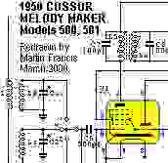
However, some applications call for a GIF or PNG instead instead. Here are some images of an engineering drawing, subject to similar treatment:
Compression 1% Compression=60% Compression 99%
Size=32.1KB size=8.4KB size=3.3KB

Clearly, at just 60% compression this image is unusable on a web site. The equivalent GIF image for this picture is crisp and perfect and weighs in at just 2.74K, smaller than the 99% compressed image seen above. Bear in mind however that the GIF image needs only 8 colours, whereas the 32KB JPG required 802 to achieve the same effect.

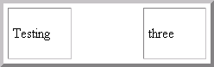
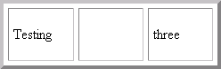
Appendix F: The ISO8859-1 Extended Character Set:
There are a great number of characters we may wish to include on our pages not readily available from the keyboard we may be using to generate HTML code; these include characters belonging to non-English character sets such as accented letters, special symbols (e.g. ©), and various currency symbols such as that denoting the Yen (¥).
The list which follows is NOT exhaustive, nor does the full list contain every character we may need. Sometimes it may be advantageous to make use of graphical image files to present such complex constructs and mathematical formulae or Greek symbols as these will display regardless of the language settings for the web browser. We may also wish to display symbols normally interpreted by HTML as having special meanings, such as < which normally tells a web browser to treat what follows as a tag rather than displaying it.
One other important code we may use frequently is the &nbsp; non-breaking space code: normally HTML converts all “white space” (spaces, tabs, new lines) between two words as a single space. Sometimes there are good reasons for employing “hard” spaces which will not be ignored after the first one is give. In addition, if you create a table and wish to show an empty cell, placing nothing within it or only a couple of spaces or a tab will cause the cell to disappear completely:
<table border="4" cellpadding="5" cellspacing="5">
<tr>
<td width="25%" height="60">Testing</td>
<td width="25%"></td>
<td width="25%">three</td>
</tr>
</table>
Whereas, employing a non-breaking space within the cell causes this to happen:
<table border="4" cellpadding="5" cellspacing="5">
<tr>
<td width="25%" height="60">Testing</td>
<td width="25%">&nbsp;</td>
<td width="25%">three</td>
</tr>
</table>
Each of the symbols listed may be typed by using the either the code or entity name listed. See a listing of the ISO8859-1 character set at: http://www.bbsinc.com/iso8859.html
Description:Sample:Code:HTML Entity Name:
Non-Breaking Space&#160;&nbsp;
Quotation Mark“&#34;&quot;
Acute accent (single quote) ‘&#180;&acute;
Ampersand&&#38;&amp;
Less-Than-Sign<&#60;&lt;
Greater-Than-Sign>&#62;&gt;
Plus or minus±&#177;&plusmn;
Half½&#189;&frac12;
Cent sign¢&#162;&cent;
Pound sign£&#163;&pound;
General Currency sign¤&#164;&curren;
Yen sign¥&#165;&yen;
Copyright©&#169;&copy;
Registered trademark®&#174&reg;

Appendix G: Hexadecimal Conversion Table:
A single byte comprises of eight bits, positioned as in the table below, which includes examples of binary numbers together with their decimal representations:

In order to simplify the representation of these eight binary bits, each group of four bits is described by a single alphanumeric digit, a Hexadecimal character. When considering each group of four bits in turn (effectively the unit’s and the sixteen's columns), the chart below can be used to find the value represented:

Example 1: Convert DA₁₆ to Decimal:
D=1101, A=10101101 1010 = 128 + 64 + 16 + 8 + 2 = 218₁₀

Example 2: Convert 127₁₀ to Hex:
127 = 64 + 32 + 16 + 8 + 4 + 2 + 1= 0111 1111 = 7F

